Industrial Performance of a Vertical Vegetated Biofiltration System for Particulate Matter and Odour Control: Two Full-Scale Case Studies in Chile
Donald Mc Leodᵃ, Trinidad Montalva Osésᵇ
ᵃ,ᵇ Filtrovivo SpA, Chile
donald@filtrovivo.cl
Vertical vegetated biofiltration systems have emerged as an alternative for the treatment of industrial air emissions in facilities where conventional biofilters may be constrained by space requirements or integration limitations. This study presents a preliminary field evaluation of a vertical vegetated biofiltration system applied to two industrial emission sources in Chile: particulate matter emissions from a biomass-fired boiler and odour emissions from an aromatic production facility. Particulate matter was measured through isokinetic sampling according to Chilean Method CH-5, based on U.S. EPA Method 5, while odour emissions were evaluated through dynamic olfactometry according to NCh 3190:2010 and static sampling according to NCh 3386:2015. In the biomass boiler application, particulate matter concentration decreased from 278.5 mg/Nm³ to 13.8 mg/Nm³, corresponding to a removal efficiency of 95.05%. In the aromatic production facility, odour emissions decreased from 2.36 × 10³ UOE/s to 3.65 × 10¹ UOE/s, corresponding to a removal efficiency of 98.45%. These results indicate that vertical vegetated biofiltration can achieve substantial pollutant reductions under industrial operating conditions. However, the findings should be interpreted as preliminary because they are based on two case studies and a limited number of measurement campaigns.
- INTRODUCTION
Biological air treatment technologies, including biofilters, biotrickling filters, and bioscrubbers, have been widely applied for the treatment of odorous compounds, volatile organic compounds (VOCs), and other biodegradable gaseous pollutants. In these systems, contaminants are transferred from the gas phase to a biologically active medium where they may be absorbed, adsorbed, retained, or biologically transformed by microbial communities. Their performance depends on operational parameters such as pollutant characteristics, gas residence time, moisture content, temperature, nutrient availability, microbial activity, and airflow distribution (Devinny et al., 1999; Shareefdeen and Singh, 2005).
Despite their demonstrated effectiveness, conventional horizontal biofilters may require large footprints and can be affected by channeling, drying, clogging, and heterogeneous airflow distribution. These limitations have motivated the development of alternative biological treatment configurations.
Among these alternatives, vegetated biofiltration systems have attracted increasing attention due to their capacity to combine biological treatment processes with vegetation and engineered substrates (Irga et al., 2017; Pettit et al., 2018; Torpy et al., 2017). However, most published studies have focused on indoor environments, pilot-scale applications, or urban air quality improvement. Comparatively few studies have documented full-scale industrial applications operating under real emission conditions.
This study presents a preliminary field evaluation of a vertical vegetated biofiltration system applied to two industrial emission sources in Chile: particulate matter emissions from a biomass-fired boiler and odour emissions from an aromatic production facility. The objective is to report pollutant removal performance during independent field measurement campaigns and discuss the potential and limitations of this configuration for industrial emission control.
- MATERIALS AND METHODS
2.1 System configuration
The evaluated system consists of modular vertical biofilter units designed to treat industrial emission streams through a combination of physical retention, gas–substrate contact, moisture regulation, microbial activity, and vegetation-supported stabilization processes. The system integrates emission capture, ducting, thermal conditioning when required, forced extraction, controlled air injection, plenum-based distribution, irrigation, and vertical vegetated filtration modules.
Air is captured from the emission source and conveyed through ducting towards the treatment unit. When the inlet gas temperature exceeds the tolerance range of the biological medium, a thermal conditioning stage is incorporated before injection into the biofilter. The air is then distributed through a plenum and injected into the base of the vertical module, flowing upward through the biologically active substrate. This configuration seeks to improve gas distribution, increase contact between pollutants and the moist porous medium, and maintain suitable conditions for biological activity.
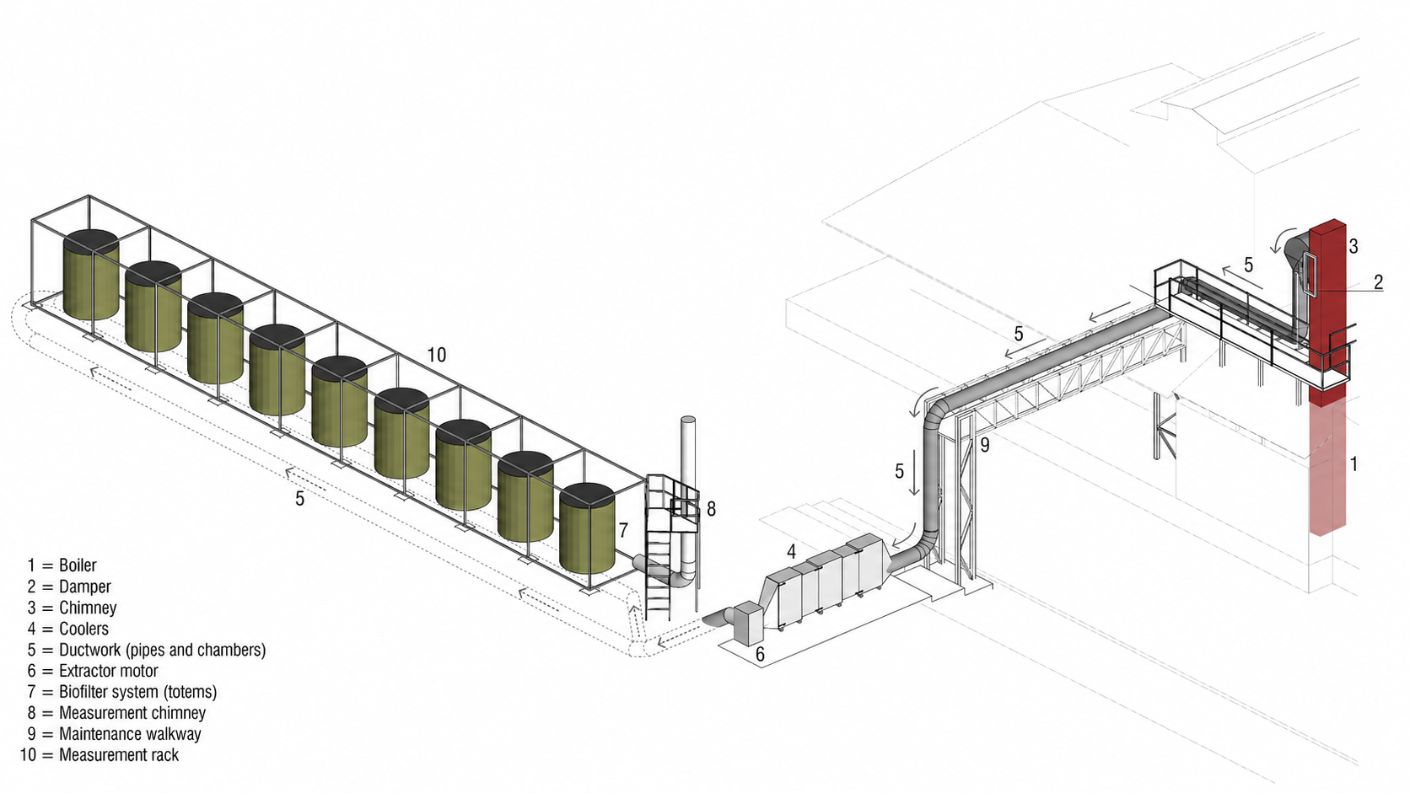
For odorous compounds, the main treatment mechanisms are associated with gas transfer into the moist biofilm and subsequent microbial degradation. For particulate matter, removal is expected to be mainly associated with physical mechanisms such as deposition, interception, inertial impaction, and retention within the moist porous substrate. Biological processes may contribute to the long-term stabilization of the medium, but particulate matter removal should not be interpreted as a purely biological degradation process.
Figure 1. Schematic representation of the vertical vegetated biofiltration system.
2.2 Case studies
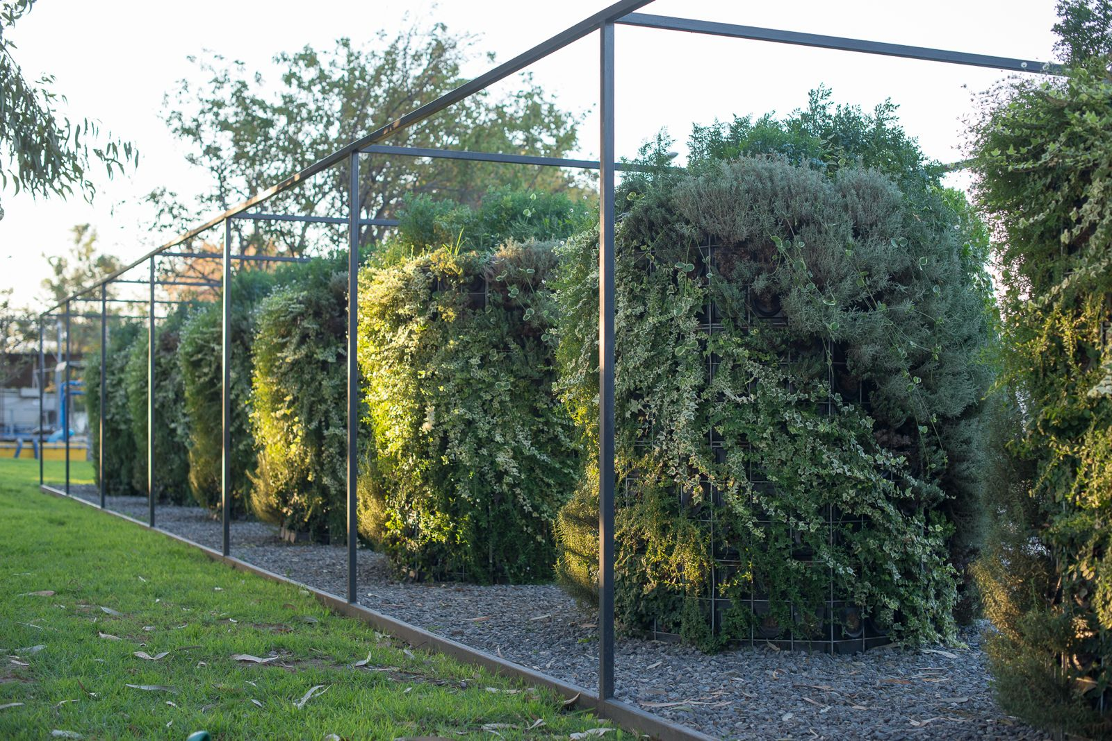
2.2.1 The first case corresponds to Comafri S.A., located in Rancagua, Chile. The emission source was a biomass-fired boiler using firewood as fuel. The gas flow was approximately 4,141 Nm³/h and was treated through a vertical vegetated biofiltration system with a total filtration area of 90 m². The inlet gas temperature was approximately 187.2 °C before thermal conditioning. Prior to entering the filtration system, the gas stream was conditioned to approximately 30 °C. In this case, the evaluated parameter was particulate matter concentration.
Figure 2. Comafri S.A Biofilter
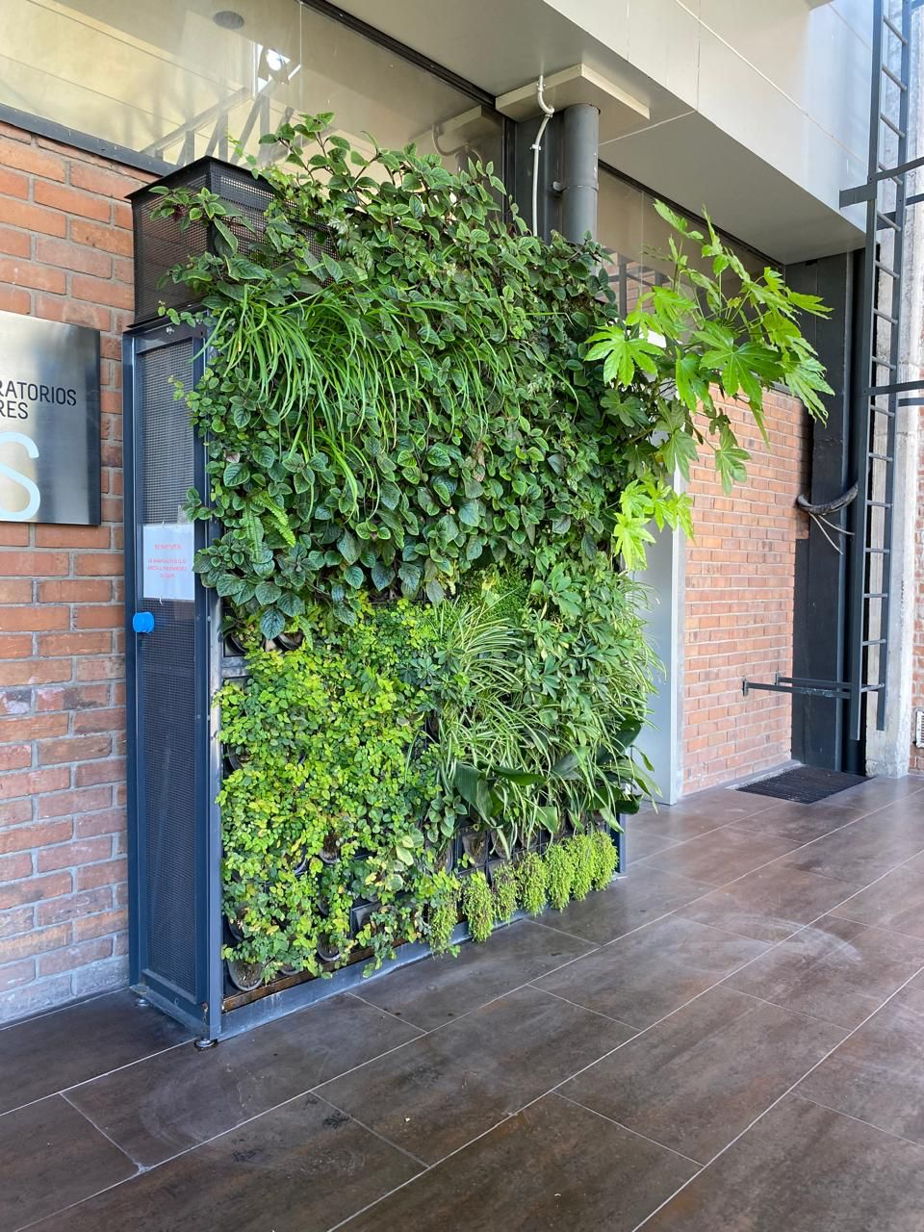
2.2.2 The second case corresponds to Cramer S.A., located in Santiago, Chile. The emission source was an aromatic production facility associated with odour emissions. The gas flow was approximately 2,435 Nm³/h and was treated through a vertical vegetated biofiltration system with a total filtration area of 8 m². As with all evaluated applications, the inlet gas stream was conditioned to approximately 30 °C before entering the biofilter. In this case, the evaluated parameter was odour emission rate, expressed in European odour units per second.
Figure 3. Cramer Biofilter
2.3 Measurement methods
Particulate matter was measured through isokinetic sampling according to Chilean Method CH-5, based on U.S. EPA Method 5 for the determination of particulate matter emissions from stationary sources. Results were expressed as corrected concentrations in mg/Nm³.
Odour emissions were measured through dynamic olfactometry according to NCh 3190:2010, harmonized with EN 13725:2003, and static sampling according to NCh 3386:2015. Results were expressed as odour concentration and odour emission rate using UOE/m³ and UOE/s.
2.4 Data analysis
Removal efficiency was calculated using the following equation:
η = [(Cin − Cout) / Cin] × 100
where η is the removal efficiency, Cin is the inlet or uncontrolled concentration/ emission rate, and Cout is the outlet or treated concentration/emission rate.
Because only one measurement campaign was available for each case, no statistical analysis, confidence intervals, or variability assessment were performed. The results therefore represent field performance during specific measurement conditions and should not be interpreted as evidence of long-term stability.
- RESULTS
3.1 Particulate matter removal at Comafri
In the biomass boiler case, the uncontrolled particulate matter concentration was 278.5 mg/Nm³. After treatment through the vertical vegetated biofiltration system, the measured concentration was 13.8 mg/Nm³. This corresponds to a removal efficiency of 95.05%.
3.2 Odour abatement at Cramer
In the aromatic production facility, the inlet odour emission rate was 2.36 × 10³ UOE/s, while the outlet emission rate after treatment was 3.65 × 10¹ UOE/s. This corresponds to a removal efficiency of 98.45%.
- DISCUSSION
4.1 Performance under field conditions
The results obtained in the two evaluated cases show high removal efficiencies during specific field measurement campaigns. In the biomass boiler case, particulate matter concentration decreased by 95.05%, while odour emissions were reduced by 98.45% in the aromatic production facility. These values suggest that the evaluated vertical vegetated biofiltration system can achieve substantial pollutant reductions under real industrial operating conditions.
However, the evidence presented in this study is limited. The analysis is based on two single case studies, each with one measurement campaign. Therefore, the results do not allow statistical treatment, assessment of variability, seasonal comparison, or evaluation of performance under different operational loads. For this reason, the findings should be understood as preliminary field evidence rather than as a definitive validation of long-term operational stability.
4.2 Vertical vegetated biofiltration as a specific configuration
The evaluated system differs from conventional horizontal biofilters through its vertical arrangement, controlled gas injection, plenum-based distribution, integration of vegetation, and compact modular design. These characteristics may help address some limitations commonly associated with conventional biofilters, including large footprint requirements, heterogeneous airflow distribution, and integration into industrial facilities with spatial constraints.
Although the available data do not permit direct comparison with conventional biofilters, the results suggest that vertical vegetated biofiltration may represent a viable configuration for industrial emission treatment under real operating conditions.
4.3 Particulate matter removal mechanisms interpretation
The particulate matter reduction observed in the biomass boiler case was high during the measurement campaign. Nevertheless, particulate matter removal in biological systems requires careful interpretation. Unlike odorous compounds or biodegradable gases, particulate matter is not primarily removed through microbial degradation. The expected mechanisms are mainly physical and include interception, inertial impaction, sedimentation, diffusion, adhesion to moist surfaces, and retention within the porous substrate.
The presence of moisture in the substrate may enhance particle capture by increasing adhesion and reducing resuspension. Vegetation and root-associated structures may also contribute to the development and stabilization of a porous matrix. However, the role of biological activity in particulate matter removal should be described as indirect or complementary, rather than as the main removal pathway.
Reported particulate matter removal efficiencies in biologically active filtration systems vary considerably depending on particle size distribution, gas velocity, substrate characteristics, moisture content, and operating conditions. Consequently, direct comparison between studies is often difficult. Although the removal efficiency observed in the present study compares favourably with values reported for several filtration-based treatment approaches, the limited number of evaluated cases prevents broader conclusions regarding comparative performance. Future studies should evaluate particle size distribution, pressure drop, substrate loading, and long-term retention capacity.
4.4 Odour removal performance
The odour removal efficiency of 98.45% observed in the aromatic production facility is consistent with the reported performance of biological air treatment technologies for odorous compounds (Devinny et al., 1999; Shareefdeen and Singh, 2005; Estrada et al., 2011). In biofiltration systems, odorous compounds are transferred from the gas phase to a moist biologically active medium where they are biologically transformed by microbial communities. The effectiveness of this process depends on gas residence time, pollutant characteristics, moisture content, temperature, nutrient availability, and microbial adaptation. Although the observed reduction was substantial, additional monitoring would be required to evaluate seasonal variability, response to fluctuating emission loads, and long-term operational performance.
4.5 Limitations and future research
The main limitation of this study is the small number of evaluated cases. Only two full-scale industrial applications were analyzed, and only one measurement campaign was available for each case. This prevents replication, statistical analysis, and assessment of temporal variability. In addition, no continuous monitoring data were available, so the study cannot demonstrate long-term operational stability.
Future research should include replicated measurements, continuous monitoring, seasonal performance evaluation, and comparison with conventional biofilters and other emission-control technologies. For particulate matter applications, future studies should evaluate particle size distribution, pressure drop evolution, substrate saturation, maintenance frequency, and possible resuspension. For odour applications, future studies should assess inlet variability, peak events, microbial adaptation, empty bed residence time, and long-term removal efficiency.
Furthermore, additional full-scale installations of the same technology have been operating and monitored through annual measurement campaigns over periods of up to four years. The availability of these multi-year datasets provides an opportunity for future longitudinal and comparative studies, enabling a more robust assessment of operational stability, performance consistency, and the evolution of pollutant removal performance under real industrial conditions.
- CONCLUSIONS
This study presents a preliminary field evaluation of a vertical vegetated biofiltration system applied to two full-scale industrial emission sources in Chile. Particulate matter concentration decreased from 278.5 mg/Nm³ to 13.8 mg/Nm³ in the biomass-fired boiler application, corresponding to a removal efficiency of 95.05%, while odour emissions decreased from 2.36 × 10³ UOE/s to 3.65 × 10¹ UOE/s in the aromatic production facility, corresponding to a removal efficiency of 98.45%.
These results indicate that vertical vegetated biofiltration can achieve substantial pollutant reductions under industrial operating conditions while offering a compact treatment configuration suitable for integration into existing facilities. However, the findings should be interpreted as preliminary because they are based on only two case studies and a limited number of measurement campaigns. Further research should focus on long-term performance evaluation and comparative assessment against conventional biofiltration systems.
ACKNOWLEDGEMENTS
The authors acknowledge Comafri S.A., Cramer S.A., and the technical support of the environmental laboratories involved in the measurement campaigns.
REFERENCES
ANAM, 2024. Medición de olores. Informe de ensayo y/o medición en sistema de abatimiento “Biofiltro Vivo”. Santiago, Chile.
CEN, 2003. EN 13725:2003. Air Quality — Determination of Odour Concentration by Dynamic Olfactometry. Brussels, Belgium.
Devinny, J.S., Deshusses, M.A. and Webster, T.S., 1999. Biofiltration for Air Pollution Control. Lewis Publishers, Boca Raton, USA.
EPA, 2017. Method 5 — Determination of Particulate Matter Emissions from Stationary Sources. Washington, DC, USA.
Estrada, J.M., Kraakman, N.J.R., Muñoz, R. and Lebrero, R., 2011. A comparative analysis of odour treatment technologies in wastewater treatment plants. Environmental Science & Technology, 45(3), pp.1100–1106.
INN, 2010. NCh 3190:2010. Calidad del aire — Determinación de la concentración de olor por olfatometría dinámica. Santiago, Chile.
INN, 2015. NCh 3386:2015. Calidad del aire — Muestreo estático para olfatometría. Santiago, Chile.
Irga, P.J., Paull, N.J., Abdo, P. and Torpy, F.R., 2017. An assessment of the potential pollutant removal performance of an active green wall biofilter. Building and Environment, 119, pp.246–257.
JHG Servicios Ambientales Ltda., n.d. Informe isocinético IN-GEV-27810. Chile.
Pettit, T., Irga, P.J. and Torpy, F.R., 2018. Towards practical indoor air phytoremediation: a review. Chemosphere, 208, pp.960–974.
Shareefdeen, Z. and Singh, A. eds., 2005. Biotechnology for Odor and Air Pollution Control. Springer.

